MASTERING the Bioanalyzer DNA High Sensitivity Chip assay ^{(Updated 04 June 2025)}

The combination of Agilent’s Bioanalyzer and the DNA High Sensitivity Chip is a useful tool in the QC of NGS libraries. However, as seen in forums such as the Ion Community (now discontinued by ThermoFisher), many facilities have had frustrating experiences with the DNA HS chip... particularly with the issue of “delayed migration”. Initially, I experienced many of the same frustrations, but now nearly all of my DNA HS chips are successful. Readers of this document should note the following:
- This document shares ideas that I consider essential to my mastery of the DNA HS chip for the QC of NGS libraries, but it should not be regarded as a “manual”.
- The goal here is to focus on issues not highlighted by the Quick-Start Guides included with the kit; thus, readers should also refer to those guides (or the full documentation).
- Finally, the linked documents in the Bioanalyzer “Help” tab contain a wealth of useful trouble-shooting information and tips on how to operate the instrument and software.

Bioanalyzer Chips and Assay Instructions

1) Chip Architecture: The image below shows how the different wells are connected and processed. This information can be used to plan where to put specific samples, and provides a basis for understanding how samples can affect other wells on a chip.
- Wells 1-6 use a common sample channel on the top half of the chip and Samples 7-11 (and the Ladder) use a second common sample channel on the bottom half.
- The ladder is run first, followed in order by Samples 1-11.
- Within the common channels, any contaminates present in the samples can gradually accumulate such that the later samples are adversely affected.
- Samples that were processed with E-gels or “Beads” cannot be run directly in the DNA-HS chip. E-Gel samples must first be purified (to remove excess salts); whereas, ‘Bead’ samples must be centrifuged and placed on a magnet (2 min) prior to taking the bioanalyzer samples.
- Most commonly, it will be Wells 5 & 6 (channel #1) & Well 11 (channel #2) that are most severely affected by contaminates; under extreme conditions, Well #4 will also be severely affected.
- Typically, even if Wells #5-6 are adversely affected, Wells #7-10 will be fairly normal, although results might be noisier than normal... particularly #7, which is run immediately after Well #6.
- Samples in Wells #7-11 tend to generate lower concentration estimates than Wells #1-6, even if running replicates of the same sample across the entire chip.
- Critical Samples: If some samples on a chip are more critical than others, the best locations for those samples are Wells #1-3, followed by #4, #7-9, & #10; worst locations are Wells #5-6 & #11. 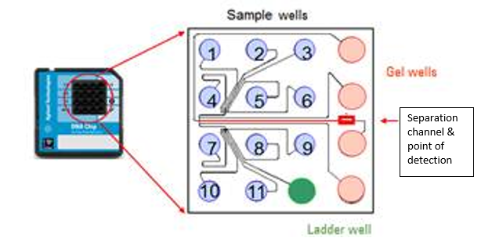
2) Kit Shelf Life: As long as the gel and dye have not been mixed and the kit has been properly stored, I find that the kit performs normally long after the official expiration date for the kit.

3) Prepared Gel Shelf Life: Best practice is to follow the manual’s recommendation to use prepared gel-dye mixture within six weeks.
- However, based on discussions with Agilent, the primary concern is the potential formation of crystals in the gel... at least as long as the dye has been protected from light.
- I have had success with using 'expired' gel by running it through another spin-filter. I have had similar success with the RNA Pico 6000 kit.
- Extra spin columns can be ordered from Agilent; do not substitute other spin columns (e.g., the spin column from a Promega Wizard kit will retain the dye).

4) Priming Station Set-up:
- The inner diameter of the holder is just barely larger than the outside diameter of the upper part of the syringe barrel, creating a very tight fit. The fit is so tight that, unless one applies a fair amount of force, the upper barrel of the syringe appears designed to stop the syringe from going farther into the holder. Nevertheless, it is necessary to press the syringe fully into the holder, and then to put the clip on the lowest setting for the DNA-HS kit.
- If desired, before actually setting up a chip, you can test the syringe by putting a new chip in the priming station, closing the assembly, and pushing down on the syringe plunger...
  - if the plunger bounces back up well after being released, everything is ready to go.
  - if not, then the assembly needs to be checked for clogs, split seal, loose syringe, or old syringe.

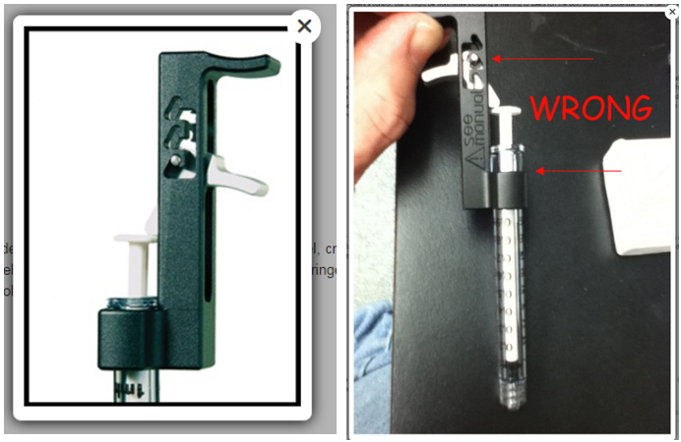

5) Reagent Preparation:
- If needed, prepare new gel according to protocol (all reagents should be at room temperature for 30 min).
- Vortex Ladder & Marker, then quick-spin tubes to settle contents.
- Place prepared Gel in hot block at 30ºC (>5 minutes prior to running chip).
- Gel Notes:
  - Previously prepared gel:
    - Before warming, centrifuge gel (5 min, ~2,450 rcf) to pellet particulates that might have formed during storage at 4ºC.
    - When pipetting, avoid drawing up gel from the very bottom of the tube.
  - Reduce exposure of gel-dye mix to light (to protect dye from photobleaching):
    - In the hot block, cover the gel tube with a light-shield (e.g., a white 125-ml bottle-cap).
    - If possible, turn lights in the room down while working with the gel-dye mix.
  - Leaving gel at room temperature (protected from light) for most of a work day does not seem to adversely affect later assays using that same gel; nevertheless, if the gel will not be used again for several hours, I recommend returning it to the refrigerator as soon as possible.

6) Instrument Preparation:
- Before starting to prepare the chip, ensure that the Bioanalyzer is on, the software is open on the PC, and the program indicates that the system is ready to run a chip.
- Select the proper kit type and edit the Run Name as desired.
- Sample names, run comments, and kit information can be added now, or at any point afterwards.
- Clean the pinset (even though it was also cleaned after the last run):
  - Insert a water-filled cleaning chip into the Bioanalyzer
  - Close the lid and wait 5 min before removing the water-cleaning chip (shake it out)
  - Leave lid open (≥5 min) to let pins dry, and then close the lid.
  - Best practice is to allow ≥20-30 min of total drying time before running a chip, although <5 min will usually be sufficient unless room humidity is high.

7) Sample Issues:
- Sample Buffer: The DNA-HS kit requires some salt in the buffer for best results, but...
  - Salt concentration must stay within the specified limits.
  - Residual beads from ‘Bead’ cleanups will create massive chip disruptions; ensure that the 1-ul aliquot is completely bead-free by first centrifuging samples & putting them on a magnet (2 min).
  - Purify samples obtained from E-gels, or the excess salts will cause severe chip disruptions.
- Minimum DNA concentration (pg/ul) of DNA samples on a DNA-HS chip
  - Varies with distribution of fragment sizes.
  - For a discrete peak (~20 bp), it’s ~5 pg/ul.
  - For discrete peaks (~20 bp, between ~200bp-400bp), the lower quantifiable limit is ~70-100 pM.
- Maximum DNA concentration of DNA samples on a DNA-HS chip
  - Varies with distribution of fragment sizes (up to ~5 ng/ul for broad smears);
  - Over an ~10-bp window (similar to a ladder peak), 500 pg/ul.
- “Replicates” & Serial Dilutions: Concentration estimates are subject to large variations, given that only 1 ul of sample is combined with only 5 ul of Marker solution.
  - For accuracy, it is best to run duplicates or triplicates of each sample so that an average concentration can be calculated (after deleting any clearly aberrant values).
  - Unless approximate sample concentrations are already known, it can be useful to run serial dilutions of each sample on a DNA-HS chip (this can substitute for “replicates”).

8) Priming Station Operation:
- Check ‘white sealing disc’ (located below syringe) for cracks/splits or gel clogs (replace/clean as needed):
  - Closing the priming station with too much force will rupture the white sealing disc... allowing air leakage when attempting to inject the gel into the chip.
  - Thus, always close assembly gently and cease pushing down on it as soon as you hear the “click”.
- Syringe: Verify that the syringe is tightly screwed onto the priming station.

9) Gel Loading:
- Pipette tips:
  - Avoid filter tips, which can shed particulates that may enter the gel and cause data spikes.
  - Using low-retention (but non-coated) tips can help with ejecting the full 9-ul of gel.
- Gel viscosity:
  - Warming prepared gel in a 30ºC hot block helps reduce gel viscosity.
  - For each gel well, use a new tip and dispense gel at a slow, steady rate (e.g., avoids chip failures from inadequate gel volume which can prevent proper contact with pinset).
  - To avoid introducing bubbles, set pipette to 10 ul, and stop dispensing at “hard stop” on pipette (vs. attempting to expel all the gel from the tip of a pipette set at 9-ul). Alternatively, use ‘reverse-pipetting’ technique noted in official protocol.
  - Examine each tip after dispensing gel to verify that most of the gel was dispensed; if not, add more gel to ensure a full 9-ul is in each gel well.

10) Gel Injection:
- After loading primary gel well, depress syringe plunger below the clip in one smooth, rapid motion.
- Release clip at kit’s specified time to prevent both ‘under-injection’ & ‘over-injection’ into microchannels.
- After releasing clip, verify pressurization by noting whether plunger pops up by ≥0.3 ml within ~1 s.
- After 5-8 s, slowly raise plunger to the 1-ml mark and open the priming station.
- Observe white sealing disc with magnifying glass; blot disc with Kimwipe if any gel is detected (prevents clogging of the chip priming station and subsequent chip failures).

11) Chip Loading:
- Gel wells: fill remaining three gel wells, following gel-loading tips above.
- Marker and Samples: There are two options for loading these items...
  - Official Protocol: Client submits enough sample/tube to exceed required volume by 2-3 ul.
    - Dispense Marker solution (5-ul, or 6-ul for ‘blanks’) into bottom of the 12 wells, using reverse pipetting and depressing plunger just to hard stop... to avoid creating bubbles.
    - Pipette Ladder first (after visually verifying volume in tip), to ensure it isn’t forgotten.
    - Samples:
      - Always visually verify that pipette tip contains ~1 ul sample before discharging it.
      - Eject the 1-ul of sample and then rinse the tip 4-5X in the Marker solution.
  - “Core Facility” protocol: Client submits 1-ul of each sample (or replicate) in 0.2-ml tubes.
    - Centrifuge tubes to settle contents.
    - Pipette 5-ul Marker Solution into all sample tubes and a tube for Ladder.
      - If <11 samples, pipette 6-ul Marker Solution into extra tubes for ‘blank’ wells.
    - Pipette 1-ul Ladder into the Ladder tube.
    - Cap and vortex all tubes (~3 rapid bursts of vortexing); touch-spin to settle contents.
    - Load all 12 wells of chip, with pipette set to ~6.5-ul (Extra volume capacity helps ensure full delivery of combined marker+sample and does not cause a problem with loading chip.)

12) Chip Vortexing:
- Set the IKA - Model MS3 vortexer at 2,000 rpm (despite manual’s direction of 2400 rpm)
  - Using 2000 rpm provides a safety factor against splashing liquid up the sides of the wells.
  - Splashed liquid can cause current leakage between wells, degrading results.
  - There are two situations that require a reduction in vortexing speed:
    - The vortexer has been used extensively, causing wear on the vortexer parts... which subsequently causes greater vibration than on a new vortexer; and,
    - The buffer (in which the template is resuspended) tends to cause foaming.
- Vortex chip for 1 min.

13) Droplets: Ensure no droplets on wall of chip wells.
- Option 1: Centrifuge chip (30 s, 100 rcf) in a Plate Centrifuge, as described below.
- Option 2: With a magnifying glass, closely examine chip for liquid splashed on sidewalls of any wells; if droplets exist, either centrifuge chip or attempt to move droplets to bottom of wells by tapping chip on table or by pushing them down with a clean pipette tip.

14) Run chip: start run within 5 minutes of loading initial gel well (to avoid evaporation of samples).

15) Data Analysis: Before worrying about sample estimates (either peaks or smears),
- Verify that the Ladder peaks ran normally (sizing and raw RFU levels).
- Verify that all Lower and Upper Markers were correctly identified for all wells.
- If needed, manually integrate either Ladder or Samples to correctly identify peaks and markers.

Plate Centrifuge technique:
Centrifuging a chip is the most efficient way to eliminate side-wall droplets and bubbles. Such droplets/bubbles can cause electrical faults and other issues. If the “Core Facility” loading protocol is followed, it is easy to incorporate the centrifugation step without exceeding the 5 minute window between loading and running the chip. Plate holders can be made from cardboard or by 3D-printing.
Note 1: Remember to not touch the underside of the wells when handling the chip.
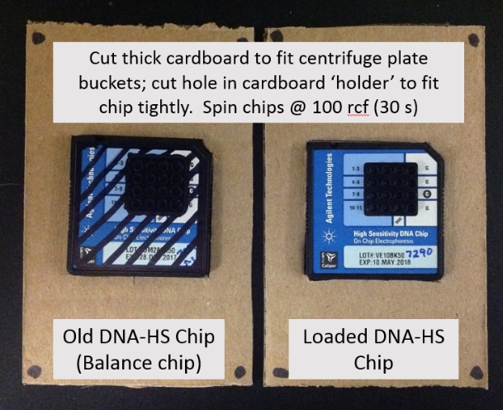
Note 2: I have not tested spinning chips for >60 s or at speeds >150 rcf; however, my recommended 30-s spin at 100 rcf is sufficient and minimizes the time to running the chip.
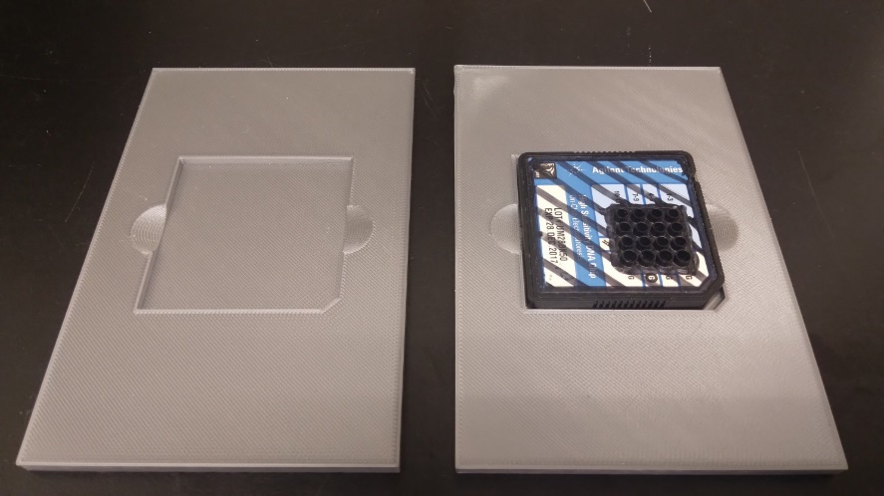
Note 3: Clearly mark the ‘used’ chip to avoid accidentally running the old chip.

Comments by Agilent Tech Support on “Delayed Migration” issues

Delayed migration of the peaks can be due to a variety of different causes, so this is not going to always be due to the same issue in labs where this symptom is observed.

- The most common cause is dirty pins, so as a first step we always recommend giving the electrode pin set a thorough cleaning if it has not been done recently. The protocol we recommend for cleaning the electrode pin set in these cases is a more thorough cleaning than the water cleaning chip that is used for routine pin cleaning between runs. This protocol is listed starting on page 155 of the Bioanalyzer Maintenance and Troubleshooting guide (look in ‘Help’, bioanalyzer software).
- Potentially this symptom could also be due to a problem with the chip priming; so when it is observed, we recommend removing the syringe adapter from the priming station and looking inside it to see if there is any evidence of dry gel debris that might be clogging it. After removing the syringe adapter, you can hold that up to a light source so you can look through it to see if it is clogged. The protocol for removing and cleaning the syringe adapter is listed starting on page 164 of the Maintenance and Troubleshooting guide.
- If anyone else in your lab uses the Bioanalyzer for other chip types, we also recommend checking the settings on the priming station base plate and the syringe clip to make sure those were not changed from the settings recommended for the High Sensitivity DNA chips (Baseplate position C, syringe clip at lowest setting).
- Delayed migration can also result from current leakage between electrodes, which results in less than the expected amount of current passing through the gel. Leak currents can be caused by:
  - the electrode pins being wet if they were cleaned and then not completely dried before they were re-installed in the instrument.
  - liquid is splashing out of the wells during vortexing. That can sometimes occur if the chip adapter on your vortexer is somewhat loose or if the samples you are running contain detergent which can lower the service tension of the liquid in the wells. Before loading any chips, we recommend manually inspecting them to see if you spot any droplets that have splashed up near the tops of the wells. If you are seeing something like that, it might help to reduce the vortexing speed to 2000 rpm.
- The humidity level in the environment being very high. If that is the case, placing the electrode cartridge in a desiccator for 15-30 minutes might resolve the issue.
- It can also help to ensure that your reagents are allowed to fully equilibrate to room temperature before setting up the chip, because if the gel is cold when the chip is primed, it can cause migration problems as well.
- Also, if the gel itself is expired or if it were stored improperly (e.g., frozen), that can affect the gel migration properties and cause an issue like this.
- Potentially, if the samples are contaminated with genomic DNA, that will also cause late migration.
- For additional help, please forward to Agilent tech support examples of some of the *.xad run files where you are observing migration issues; the raw data can also assist us in troubleshooting the issue.

DEEP-CLEANING PROTOCOL

Sometimes, the pinset can become contaminated with substances that adversely affect migration of samples and Markers through the chip. The following highly aggressive cleaning protocol is adapted from an internal Agilent R&D protocol used to reliably remove the Lipoprotein dye (basically when running protein application), which can stick tenaciously to the pins. For less contaminated pinsets, Step 4 (sonication) is optional; Step 5 is needed only if Step 4 is done.

----------------------------------------------------------------------------
Note: Use gloves!

- Turn off instrument and remove the electrode pinset from the cartridge.
- RNAse-ZAP:
  - Place pinset upside-down (i.e., pins up) in a narrow beaker.
  - Add enough RNAse-ZAP to cover pins.
  - Soak pinset for ~5’.
  - Brush pinset with RNAse-ZAP (~1’) using a soft-bristle toothbrush.
- Rinse #1:
  - Rinse pinset with a flow of de-ionized water (~1’).
  - Rinse pinset with a flow of Nanopure (18 megaOhm) water (~1’).
- Sonication:
  - Add 100 ml of a 5% disinfectant cleaning solution (e.g., ‘Oakite Sanitizer 1’ or ‘Stammopur DR’) into beaker.
  - Add water to the sonication bath.
  - Add the beaker with the pin set in the cleaning solution into the sonication bath.
  - Sonicate for 15 min.
- Rinse #2:
  - Take pinset out and clean/flush thoroughly with de-ionized water (at least 1 min).
  - Rinse pinset with a flow of Nanopure (18 megaOhm) water (~1’).
- Dry thoroughly (either with ‘canned air’ or overnight on a lint-free paper).
- Re-install the electrode pinset:
  - Run the “Short-circuit” diagnostic test before running an actual chip.
  - Re-dry if pinset fails the test, and then re-run the test.

